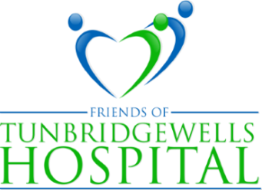

PRESIDENT: LADY MILLS PATRON: THE VISCOUNTESS DE L'ISLE

Website: [www.friendsoftwhospital.org](http://www.friendsoftwhospital.org.uk)

Tunbridge Wells Hospital Tonbridge Road Pembury Tunbridge Wells Kent TN2 4QJ

**THE LEAGUE OF FRIENDS NEWSLETTER 2025/26**

***Welcome to our 2025/26 Newsletter***

With pressure on NHS budgets more intense than ever the League of Friends is continuing to support the Tunbridge Wells Hospital through our fundraising efforts and this year we have decided to do things a little differently.

We will not be running our Grand Christmas Raffle, and instead we are excited to be launching our Help a Heart Campaign, through which we aim to raise the sum of £15,000 to provide a Corpuls mechanical chest compression machine for the hospital. In the months ahead we will be organising various fundraising events as part of the campaign and it is our hope that our members will also want to support it. Details of this important piece of equipment as well as how to donate to Help a Heart are below.

In November Diana and Colin Barber will be hosting their very last coffee morning at their home in Bidborough. From the first one in November 1991 these coffee mornings have raised more than £95,000 for the League and the aim is to top £100,000 with this final event. This is an amazing amount and a reflection of the magnificent effort put in by Diana, Colin and their team of helpers over so many years, for which I thank them on behalf of us all.

***Gary Purdy, Chairman***

**Corpuls Chest Compression Machine and Help a Heart Campaign**

In the past year from April 2024 to March 2025, there have been 132 cardiac arrests in hospital within the Trust, averaging a cardiac arrest in hospital every two to three days.In circumstances like these,the Corpuls mechanical chest compression is a machine that can take over the human role of providing high quality chest compressions to circulate blood to the heart and brain, especially in prolonged resuscitation attempts where human fatigue and staff resources may be a major issue. It can maintain high quality compressions during transfer between departments and hospitals for specialist care and its use frees staff up for other duties. It also adds to staff safety as providing prolonged chest compressions is physically exhausting and often causes muscular injuries. It is the only device on the market that is licensed for use on all category of patient. Many hospitals, as well as ambulances, already have the Corpuls machine and our aim is to make this available to Tunbridge Wells as soon as possible.

There are various ways to donate to our Help a Heart campaign: you can scan the QR code below; pay your donation directly into our CAF bank account, sort code 40 52 40 number 00010942, with Help a Heart as the reference; send a cheque, made payable to the League of Friends of Tunbridge Wells Hospital, to the Treasurer, 22 Allington Drive, Tonbridge, TN10 4HH

Whichever method you choose and however large or small, any donation is greatly appreciated and regular updates on the progress of Help a Heart will be available on our website.

Our October and November table sales, as well as an extra Christmas sale in December, will all be dedicated to Help a Heart.

**The ICU Sensory Garden**

A once bare and unwelcoming area outside the Intensive Care Unit is being transformed into a colourful, flower-filled patio thanks to a generous bequest of £5,000 in the will of the late David Nicholson.

David worked as Deputy Administrator at what was then Pembury Hospital, for most of his working life and his late wife Joyce worked in the pathology lab. After much discussion between their family and the League it was decided to create a sensory garden for the patients in the Intensive Care Unit in memory of David and Joyce.

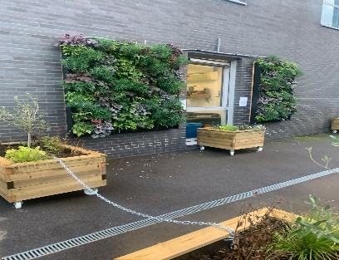A living wall has now been created, where before there was only grey brick and the newly constructed planters and pergola, filled with fragrant plants and colourful climbers, will be visible from the ward when they start to blossom in the Spring and summer of next year.

This new area will be exclusively for the use of ICU patients and will enable them to meet their visitors and even their much-missed pets outside. As well as seating, beds can be moved outdoors, weather permitting.

None of this would have been possible without the hard work and commitment of landscape gardener Tim Schooley, ably assisted by his sons, in what has been a very challenging task. Thanks also to many others who contributed: Men in Sheds, Provender Nursery for the PlantBox living wall units, Pipers Farm for the metal posts and Tate Fencing who supplied the postcrete, not forgetting How Green Nursery and Mayfield School ceramics department. Above all, thank you to the Nicholson family for their patience and support. An official opening is planned for the end of October.

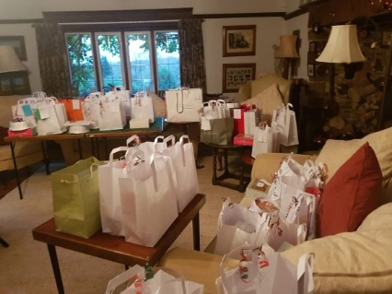**Diana Barber’s coffee morning** – Diana’s final coffee morning will be held on 13th November and will be greatly missed by everyone in Bidborough, where it has been a major event on the village calendar since 1991. Even Covid and lockdown didn’t manage to interfere as during those difficult days Diana and her helpers took well over a hundred Christmas orders, which were then safely collected or delivered to the recipients. (see right) Our grateful thanks to Diana, Colin and everyone involved for everything they have done over the past 34 years. They will be a hard act to follow and their amazing achievement and the amount that these coffee mornings have contributed to the funds of the League of Friends will leave a gap which will not be easy to fill.

**Fundraising**

Fundraising will of course continue over the next year, with a Race Night planned at Langton Green village hall in April and the ever-popular monthly tables sales, which as well as providing income, raise the profile of the League within the hospital.

The Tonbridge Model Engineering Society (TMES) supports us every year with the donations for its August Bank holiday rides, which this year amounted to over £700. A record amount and a fun afternoon!

For further details of all the above and other ways you can support us see below.

**Visit** [**www.friendsoftwhospital.org**](http://www.friendsoftwhospital.org) for more information on how to become a member, how to donate, how to raise money for the League when shopping on-line and much more.

***Thank you***