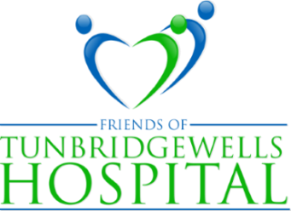
PRESIDENT: LADY MILLS PATRON: THE VISCOUNTESS DE L'ISLE
Website: www.friendsoftwhospital.org
Tunbridge Wells Hospital Tonbridge Road Pembury Tunbridge Wells Kent TN2 4QJ

THE LEAGUE OF FRIENDS NEWSLETTER 2023/24
Welcome to our 2023/24 Newsletter.
The past year has been a challenging one for charities everywhere and the TW Hospital League of Friends is no exception as we are aware that our members and supporters are all affected by the current financial climate. We have continued with our usual fundraising activities, and I am pleased to say that this, combined with donations and legacies, has enabled us to support many of the requests that we receive from patients and staff. These requests can range from a few hundred pounds to several thousand and all are intended to improve the experience of those attending the hospital, whether as in- patients, outpatients, A & E or simply visiting friends and family.
A few months ago, we were particularly pleased to be able to agree to the refurbishment and decoration of the paediatric ward playroom to provide a much brighter and welcoming space for the young people staying there. It is only the generosity of our members and supporters that makes this possible and allows us to continue to do so.
With sincere thanks and best wishes
Gary Purdy, Chairman
Diana Barber’s coffee mornings
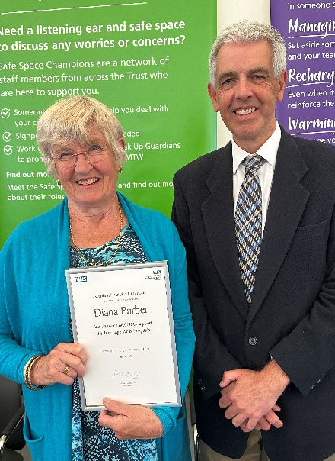
Diana’s coffee morning which she holds every November is without doubt one of the main fundraising events of the League’s calendar. Diana has been welcoming people to her home in Bidborough for over 25 years to enjoy a variety of Christmas stalls and delights and has raised over £86,000 in the process. This remarkable achievement was recognised at a recent occasion to mark 75 years of the NHS, when Diana was surprised and delighted to receive an Exceptional Service Certificate.
Pictured here with our chairman Gary Purdy, Diana said that she has a dedicated team of helpers who make this possible and paid tribute to them for everything they have done over the years to help her make the coffee mornings such a success.

Raffle and prizes
Our Grand Christmas Raffle continues in popularity, raising over £2,000 last year. Tickets will be on sale in the main reception area of the hospital in the weeks leading up to the draw on 13th December by our president Lady Mills. The first prize of £300 has once again been generously donated by Salomons Estate Country House and the second, which is M & S vouchers worth £250, again donated by The Knee Clinic with further prizes of £250, £200, £125 and more. Details of all these are available on our website and the winning ticket numbers will appear in due course.
Requests
The requests the League receives from the hospital vary enormously. Details of some that have been funded in the past as well as more recently are on our website, www.friendsoftwhospital.org, but in the last twelve months we have provided items ranging from phlebotomy trolleys to furniture for the psychiatric assessment room, and from a 50 inch Smart TV to the refurbishment of the paediatric ward playroom, the latter at a cost of just over £5,000.
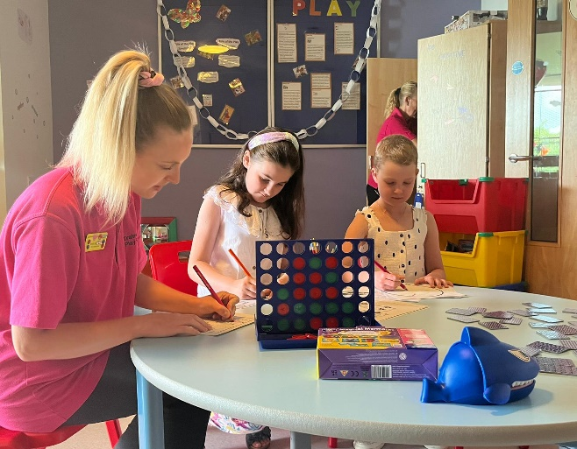
The ward has been redecorated in bright and attractive colours with new furniture and the views of the young patients and nursing staff were consulted beforehand to ensure that their surroundings and working environment are as comfortable and stimulating as possible.
Isobel, who is on the far right in the picture, was diagnosed with Acute Lymphatic Anaemia in 2022 and is receiving ongoing support. She and her friend are enjoying some of the new play equipment and colouring sets also provided by the League.

Our table sales on the last Friday of the month have gone from strength to strength thanks to the efforts of Francis Grimes and her dedicated helpers, led by Sue Marsh (third from left) and Doreen Lamberton-Kerr (second from right) who set up early to display the wide variety of goods that are on sale.
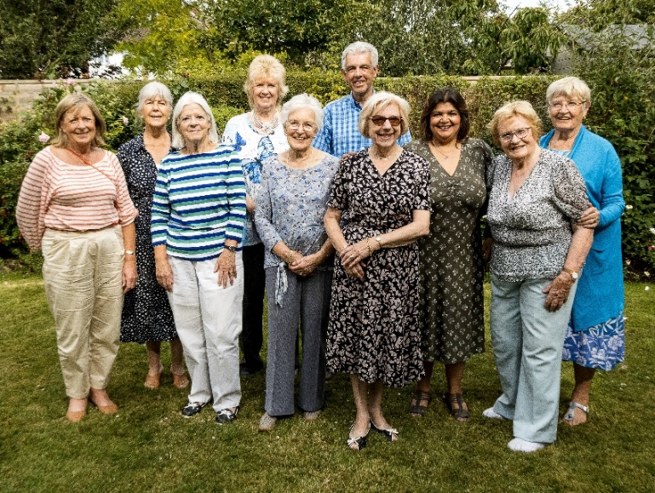
Tonbridge Model Train Day on the Sunday of August bank holiday weekend always draws in a lot of eager passengers of all ages, and various council members turn up on the day to help the train drivers collect donations, control the enthusiastic passengers (and enjoy the occasional train ride themselves).
Our picture shows Gary Purdy, with Francis on his left, surrounded by a smiling group of council members, all enjoying a summer tea party in Doreen’s delightful garden.
And finally …….. how you can support us - Buy some of the enclosed raffle tickets! Become a member! Tell your friends!
To donate to the League, scan in the QR code or visit our website www.friendsoftwhospital.org for details of how to do all this, as well as how to raise money for the League when shopping on-line.
Thank you.

