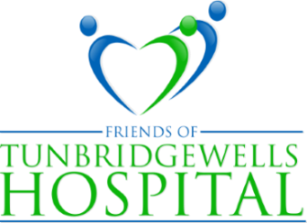
PRESIDENT: LADY MILLS PATRON: THE VISCOUNTESS DE L'ISLE
Website: www.friendsoftwhospital.org
Tunbridge Wells Hospital Tonbridge Road Pembury Tunbridge Wells Kent TN2 4QJ

THE LEAGUE OF FRIENDS NEWSLETTER 2022/23
Welcome to our 2022/23 newsletter
As I write this in late September we have just mourned the death of our late Queen Elizabeth, and welcomed both a new monarch and a new prime minister. These are challenging times for us all and there cannot be many who have not been affected, either directly or indirectly by the Covid pandemic and all that entailed. We owe a huge debt to the NHS staff at Tunbridge Wells hospital for their dedication and hard work during this period and they continue to need our support.
On a positive note, our highly popular tables sales have resumed, held as before on the last Friday of the month and the Tonbridge model railway Sunday has been as well supported as ever, with no upper or lower age limit for the passengers, as you will see below.
Early in the year I collected a cheque for £1,205 from the ladies of Poult Wood Golf club as their captain had chosen the League as her charity of the year. Not only does this contribute to our funds, but as with the Model Railway Day, it raises the profile of the League and makes others more aware of what we do.
While no one is certain what 2023 will bring, I do know that it is generous donations such as these, as well as the support of our members that have enabled the League to help the hospital, its patients and its staff and to continue to do so in the year ahead.
With sincere thanks and best wishes
Gary Purdy, Chairman
Tonbridge Model Railway Society
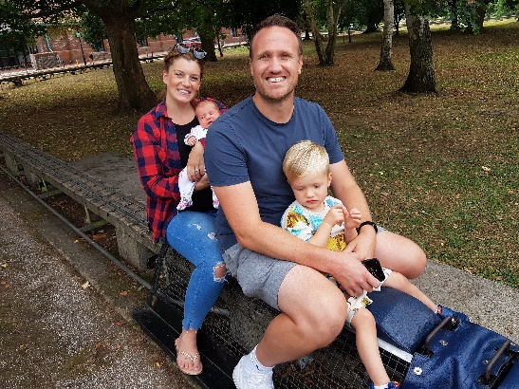
On the Sunday of the August bank holiday weekend, the Model Railway Society kindly donates all its takings to the League of Friends. We always seem to be extremely lucky with the weather and have enormous support from the people of Tonbridge and indeed much further afield, who enjoy rides on the electric, diesel and steam trains expertly made and maintained by the Society’s members. This year, our youngest passenger (secure in the arms of her mother Lorna) was Scarlett Flisher, who was born in Pembury only eight weeks earlier. Her brother Oakley, supported by dad Darren, is taking it all in his stride. 2022’s event raised nearly £500 and we are as ever, hugely grateful to the Society’s members for supporting the League in such a fun way.
Raffle 2022
As Covid restrictions relax, raffle tickets will again be on sale in the main hospital entrance on certain days, as well as being sent out to members in our end of year mailing. This year’s first prize of £300 has been generously donated by Salomons’ Estate Country House with a £200 voucher given by the Knee Clinic and a third prize of £100 from Brook Decorations (London) Ltd. We are most grateful for these as well as the variety of smaller prizes that have been given. The 2021 raffle raised £2,143 so it would be great to exceed this.
Poult Wood Ladies Golf
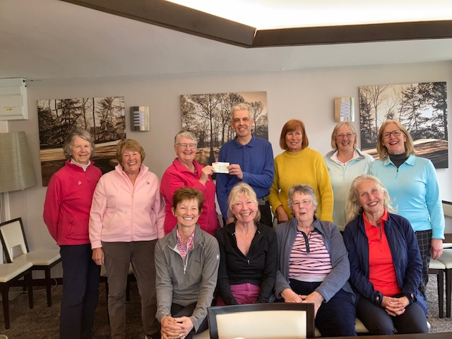
On the left our chairman Gary Purdy is shown surrounded by the smiling ladies of Poult Wood golf club as he receives a cheque for £1,205 from their captain, Joanna Osborn. Thank you Poult Wood! Enjoy your golf.
Open Garden Evening
Our president Lady Mills’ open garden has become something of an annual event and the wonderful display of roses and vibrant borders are testament to the skill of the gardeners, who have faced some very challenging weather conditions this year. As well as resulting in £1,500 for the League, this was a happy and sociable occasion for all who came to visit. Our sincere thanks to Lady Mills for sharing her garden with us.
Diana Barber’s coffee morning
Without a doubt Diana’s annual coffee morning is a fundraising highlight of the League’s year and a much-anticipated event in Bidborough. However, in June the bric-a-brac which is normally sold at the coffee morning was relocated to the Bidborough Jubilee fete where the League took a stall. This provided a wonderful opportunity to promote the work of the League and to explain what we do, as well as to sell pre-loved items of chinaware, glass, paintings and kitchen ware. In 2021 the coffee morning raised £5,275 thanks to the tremendously hard work of Diana and her team of helpers. This year it will be on Thursday 17th November and will be a chance to buy early Christmas presents, as well as cards, decorations, and a wide selection of Christmas goodies.
Table Sales
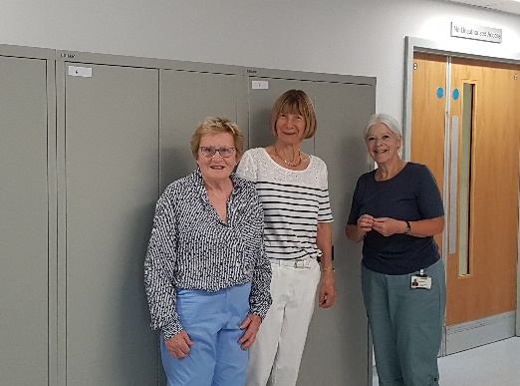
The return of the table sales to the main reception area of the hospital has been warmly welcomed by everyone. The cakes are as ever fast sellers, together with jams, (jumbleberry jam anyone?) and chutneys. But books, cards, knitted goods and toiletries are also available and need to be packed away at the end of every session. Storage is always a concern and we are delighted the hospital has supplied a row of cupboards close to the main reception, where these items can be kept safely till they are needed.
From left to right, table sales helpers Doreen Lamberton Kerr, Julia Armstrong and Sue Marsh inspect the recently installed cupboards, which have greatly increased the League’s on-site storage capacity.

And finally …….. how you can support us - Buy raffle tickets! Become a member! Tell your friends!
To donate to the League, scan in the QR code or visit our website www.friendsoftwhospital.org for details of how to do all this, as well as how to raise money for the League when shopping on-line.
Thank you.

