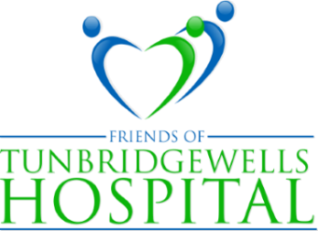
PRESIDENT: LADY MILLS PATRON: THE VISCOUNTESS DE L'ISLE
Website: www.friendsoftwhospital.org
Tunbridge Wells Hospital Tonbridge Road Pembury Tunbridge Wells Kent TN2 4QJ

THE LEAGUE OF FRIENDS NEWSLETTER 2021/22
Welcome to our 2021/22 newsletter.
When I wrote my newsletter message in 2020, little did I anticipate that in Autumn 2021 we would still be under the shadow of Covid, albeit with a large proportion of the population vaccinated and the country gradually opening up again. Like so many other organisations, the League has had to adapt to a new reality, holding meetings on-line, curtailing some of its usual fundraising activities and being more imaginative with others. More of this below.
During the lockdowns council members have organised deliveries to the hospital for the personal use of staff, such as soft drinks, biscuits, chocolates, toiletries and luxury items, all of which were willingly donated by local firms, organisations and individuals as a token of their appreciation. Our website www.friendsoftwhospital.org shows how even CEO Miles Scott was on hand to help in the distribution.
While no one is certain what 2022 will bring, I do know that it is the generous donations and support of our members and many others that have enabled the League to help the hospital and its staff in these difficult times and to continue to do so in the year ahead.
With sincere thanks and best wishes
Gary Purdy
Chairman
Diana Barber’s Coffee Morning - November 2020
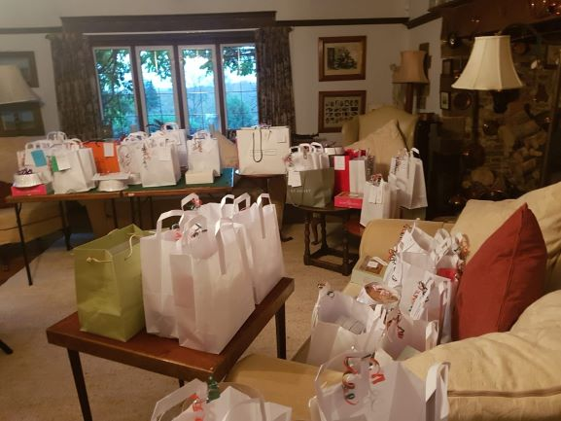
Diana’s coffee morning, which is always a hugely popular and successful event held in November had to take a new format and as a result Diana decided that with the help of her friends she would take orders for homemade Christmas goods and either deliver these or set a day for them to be collected.
This arrangement proved a great idea and the picture on the left shows just some of the items ready for collection. The final total raised was £6,800, a new record, and one that involved a great deal of hard work and organisation. Diana is extremely grateful for the help she was given by so many.
11 November has been set as the 2021 date and we wait to see if this can go ahead depending on current restrictions.

Grand Christmas Raffle 2021
The Grand Christmas raffle will be held again, though selling in the hospital entrance will not be possible. To make distribution simpler there will be three main prizes of £300, £200, and £150 as well as some minor ones and raffle tickets will be sent out to members and supporters, as well as being enthusiastically sold by our committee. We hope that you feel able to buy some and persuade your friends to do the same. The 2020 raffle raised £2,800 and it would be wonderful to equal or exceed this.
Open Garden Evening – June 2021
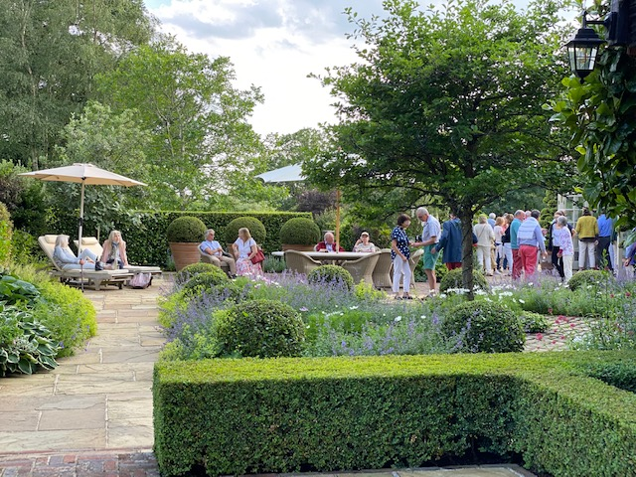
Fortunately, some outdoor events were allowed to go ahead and in June our president Lady Mills opened her garden in aid of the League. In contrast to previous days, the sun came out and visitors were able to enjoy a wonderful evening of roses, lavender and much, much more.
The evening raised £1,800 and we are so grateful to Lady Mills for welcoming us and to her gardeners and staff for ensuring that everything looked stunning, despite some very challenging weather conditions.

Tonbridge Model Train Run 2021
The tracks and trains of Tonbridge Model Engineering Society are located in the Slade, just behind Tonbridge swimming pool. Sunday of the August bank holiday was an opportunity for youngsters and their parents to enjoy a ride on models of steam, diesel and electric trains made by members of the society in return for a donation to the League. There was no lower or upper age limit, the only consideration being the safety of the passengers (and their drivers). This event raised over £430 for our funds and gave young and old a chance to admire and travel on these wonderful models. Our grateful thanks to the Society for supporting us again this year.
Volunteers’ Thank You Picnic Day 2021
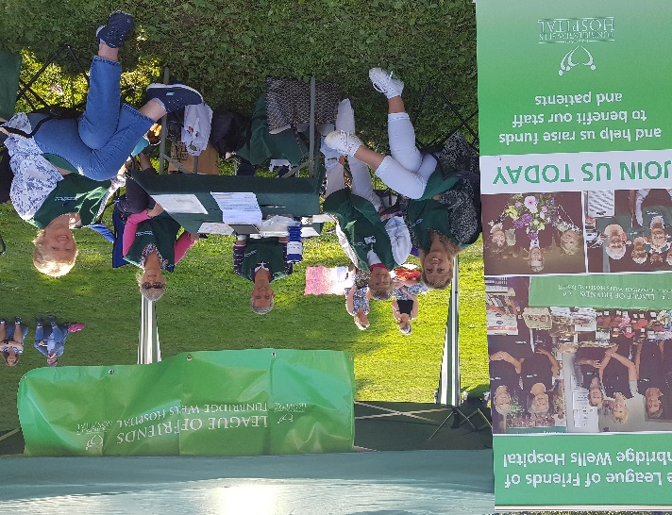
On September 18th Tunbridge Wells Borough organised a picnic day in Calverley grounds as a thank you for the local and national charities that have been operating under the restraints of the pandemic. There were 35 stalls set out and the League was delighted to be invited to take part. It was a wonderful opportunity to get to meet other charitable organisations, compare notes and raise the profile of the League.
Pariticipants were entertained by singers, dancers and even an orchestra and provided with a picnic to enjoy.
The picture on the right shows chairman Gary Purdy and council members making the most of the afternoon sunshine.
And finally …….. how you can support us - Buy raffle tickets! Become a member!
To donate to the League, scan in the QR code or visit our website www.friendsoftwhospital.org for details of how to do all this, as well as how to raise money for the League when buying items online. Thank you.

