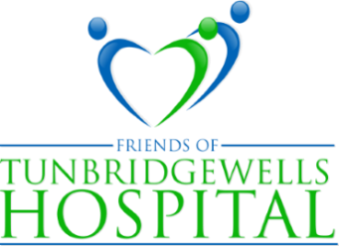
PRESIDENT: LADY MILLS PATRON: THE VISCOUNTESS DE L'ISLE
Website: www.friendsoftwhospital.org
Tunbridge Wells Hospital Tonbridge Road Pembury Tunbridge Wells Kent TN2 4QJ

THE LEAGUE OF FRIENDS NEWSLETTER 2020/21
Welcome to our 2020/21 newsletter.
How the world has changed since I wrote my piece for last year’s letter! The Covid.19 pandemic has affected all our lives and with support for our magnificent NHS needed more than ever, the League of Friends has rallied to the cause. Although our normal fundraising activities have been greatly curtailed, you can read below how the League is adapting to the challenge. More details are on our website, www.friendsoftwhospital.org which has recently been redesigned and upgraded.
We are most grateful to our members and supporters for all the gifts, donations and offers of help that we have received and continue to receive through these difficult times. They are needed now more than ever.
We look forward to a time when the pandemic will be over, but in the meantime thank you for your support and we hope that you and all those close to you stay safe and well.
With best wishes from us all.
Gary Purdy - Chairman
Table Sales
Since their introduction early in 2019, our table sales, held on the last Friday of the month in the main hospital entrance have proved extremely popular and raised a very welcome amount of money for our funds. Understandably selling inside the hospital is no longer possible, but Francis Grimes who is in charge, has not been daunted and held an out of doors but under cover sale twice in September. More outside table sales are planned - weather permitting – until we are able to resume inside.
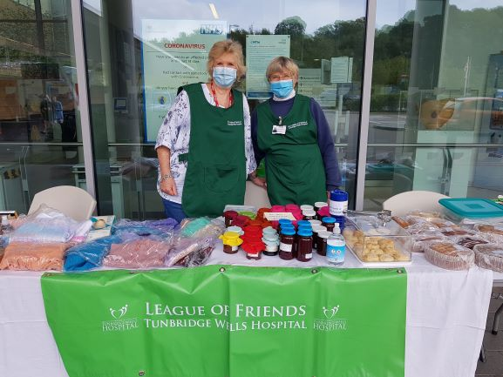

Francis Grimes and Diana Barber, masked up and braving the cold.
Cakes, jams, chutneys as well as beautiful knitted goods, cards and books are sold.

Diana Barber’s Coffee Morning
Diana’s coffee morning, a hugely successful annual event in Bidborough, will not be going ahead, but lists are being sent out for home-made Christmas goods that Diana and her helpers will be making to order, ready for collection on certain days in November.

Some words of thanks from Miles Scott, CEO of the Trust and
Sally Foy, Divisional Director of Nursing for Medicine and Emergency Services.
On behalf of the Trust, staff and patients, we would like to say a very big thank you to the League of Friends of Tunbridge Wells Hospital for its continued support.
Over the years the League of Friends has fulfilled numerous requests to fund items that aim to improve the patient’s experience, ranging from specialist medical equipment so our teams can provide outstanding care to patients, to some of the finer touches that can help make patients feel more comfortable whilst they undergo their treatment, all of which is provided by our exceptional staff.
Even during the pandemic the charity’s support never wavered. Thanks to their efforts we now have more trolleys in our Emergency Department to support the new ways we are currently working to help keep patients safe from the virus. New furnishings have also been ordered for the day rooms that are used by patients who have been diagnosed with dementia. League members even provided our staff with refreshments during these challenging times to help keep their spirits high.
Words really are not enough though to describe how truly grateful the Trust is for everything the League of Friends has done.
Thank you
Miles Scott CEO of the Trust and
Sally Foy Divisional Director of Nursing for Medicine and Emergency Services.
Lockdown Donations
In order to show its support for the hospital and its staff a group of dedicated volunteers from the League delivered a full carload of donations every week from March to the middle of June to the Post Grad centre where Chris White and her team organised the distribution.
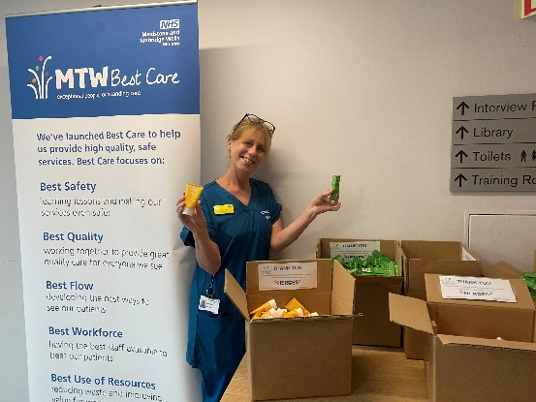
These deliveries Our thanks go to everyone contained gifts of food, who donated so generously and provisions and wash to our wonderful hospital staff,
bags from local
who have worked so bravely and
communities as well
tirelessly during these difficult
as luxury products
times.
from large companies
such as Weleda.

Grand Christmas Raffle
This has been a very different year for everyone, but regardless of the Covid restrictions, there will be a Grand Christmas Raffle as usual. There will be three main prizes of £300, £200, and £150 and other prizes that can be posted to the winners. Selling tickets in the hospital entrance area will be out of the question, but tickets are being sent out to members and supporters to purchase, as well as being enthusiastically sold by our committee members. We hope that you feel able to buy some and persuade your friends to do the same.
How you can support us
Buy raffle tickets! Our website www.friendsoftwhospital.org also gives details of how to donate, and how to raise money for the League, when you shop online.

